Extended-Abstract Template (Times New Roman 14 PT, Bold)

A.B. Chen¹, D.E. Fu*² and G. Huang^{#1}
¹Department of ABC, University of XXX, Jiangsu, China
²Department of IJK, University of YYY, Hong Kong SAR, China

*Corresponding author: xxx@yyy.zzz
# Presenter: aaa@bbb.ccc

Authors should submit an extended-abstract written in English or Chinese, including supporting figures, within one A4 page with one-inch margins. If written in English, Times New Roman 12 pt should be used. If written in Chinese, 细明体 12 pt should be used. Please follow font types, styles and sizes as in this template. A figure caption should be inserted below the figure. Authors are reminded to ensure the resolution of figures to be high enough. Please try to modify this template to form your submission.
Please submit the 1-page extended abstract and required registration information through the link: https://www.wjx.top/vm/tUehHdF.aspx before 28 February 2026. HKSTAM will send an invitation letter to non-local participants upon request.

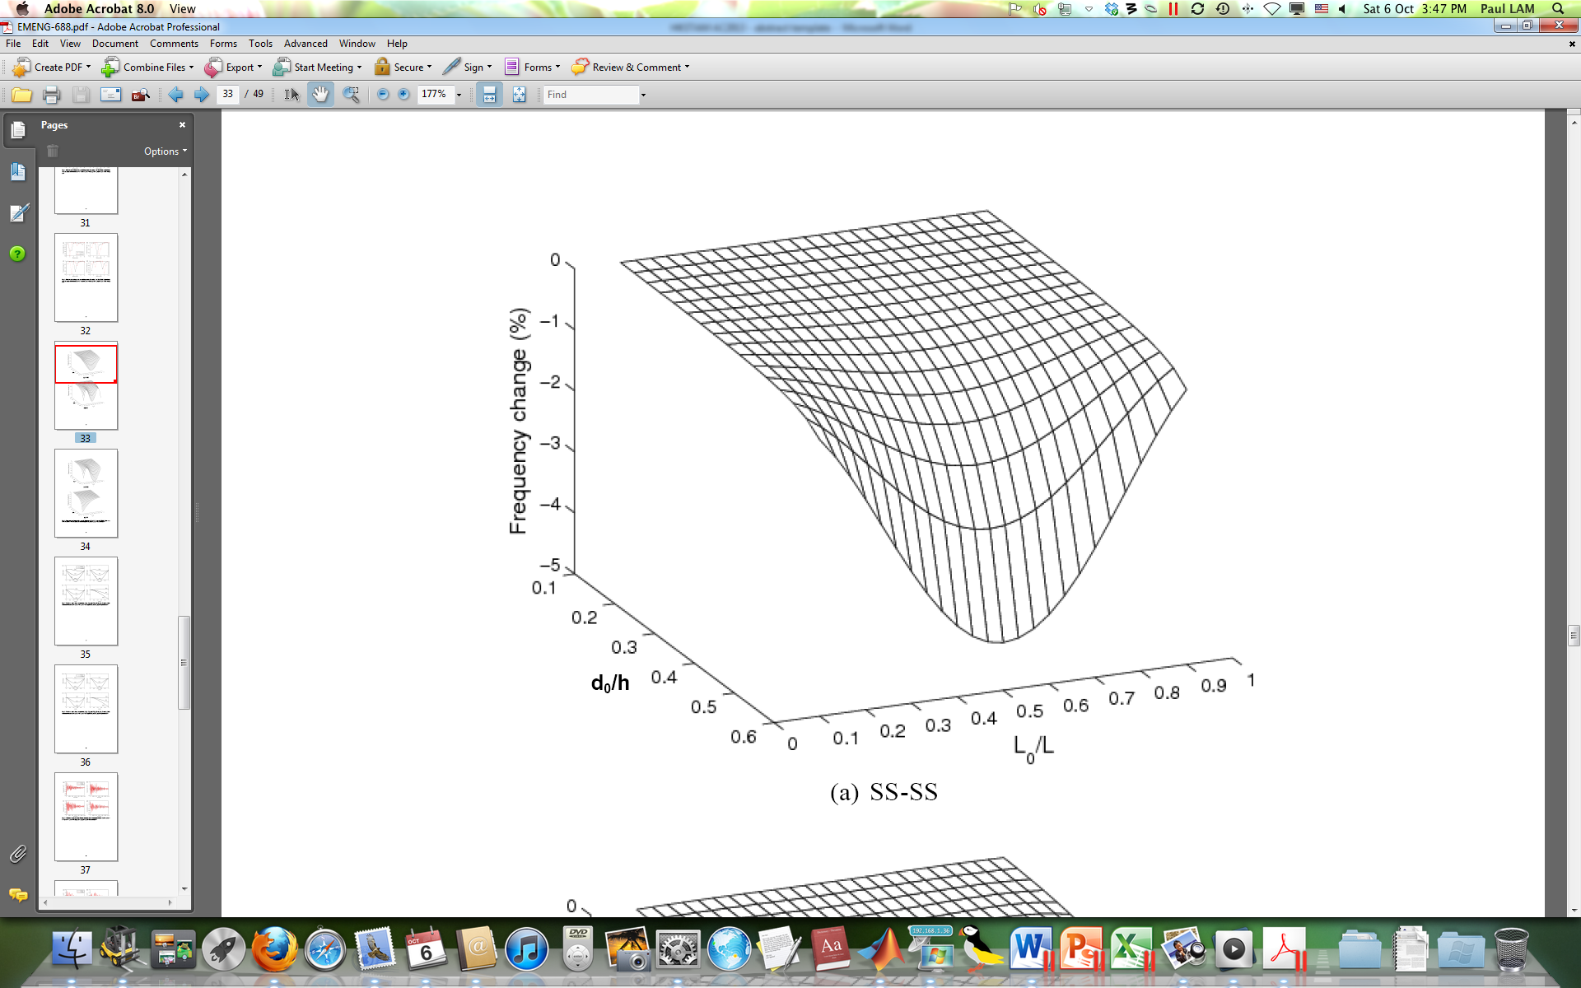
Figure 1. A sample of a figure (the caption is in Times New Roman 10 pt).

Acknowledgements
The authors wish to thank …. (in Times New Roman 12 pt). This section is optional.

References
Haldar, A. and S. Mahadevan (2000), Probability, Reliability and Statistical Methods in Engineering Design, Wiley, New York.
Kareem, A., C.C. Hsieh, and M.A. Tognarelli (1998), “Frequency-domain analysis of offshore platform in non-Gaussian seas,” ASCE Journal of Engineering Mechanics, 124(6), 668–683.

